Citizens’ Jury Report
25th March 2018
Compulsory Third Party Insurance

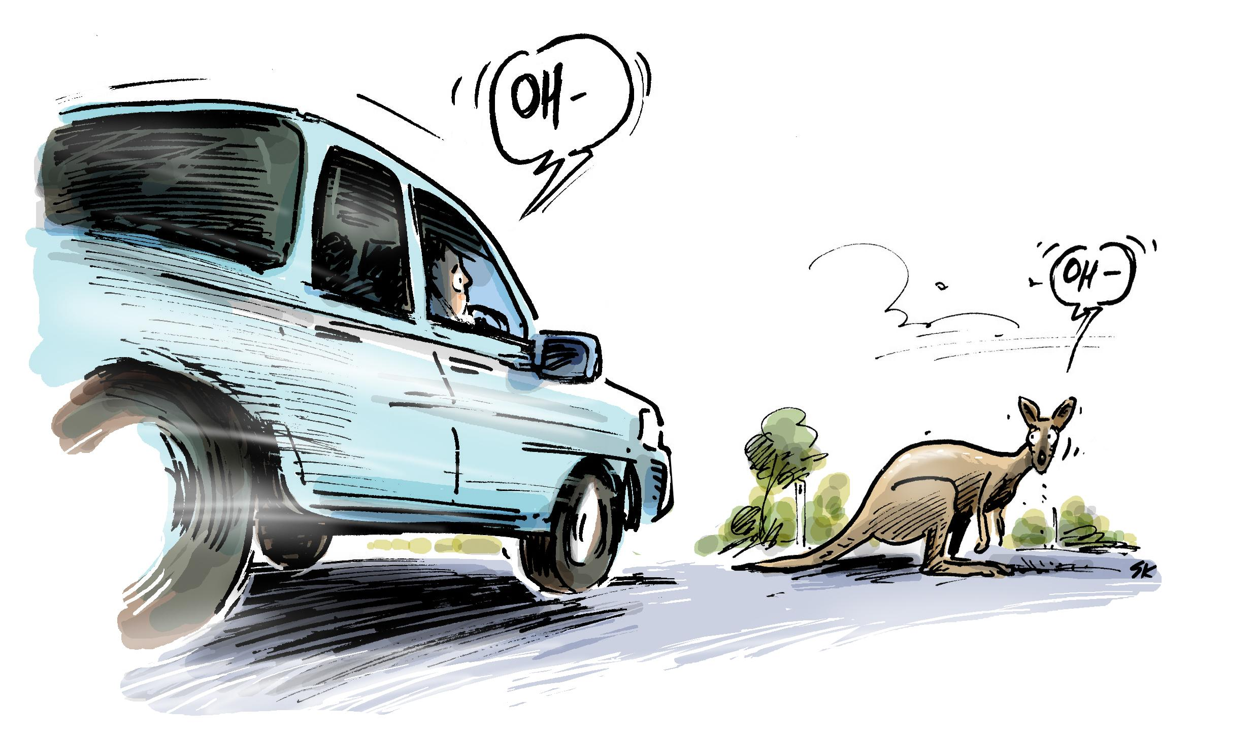

Jury Remit: What CTP model best meets the objectives as defined by Jury 1? What’s important to communicate to the community about the scheme?

Preamble
The ACT Citizens’ Jury was established to consider the current Compulsory Third Party (CTP) scheme and how it may be improved. The current scheme primarily covers injured people who can prove not to be at fault in a motor vehicle accident.

The Citizens’ Jury is a diverse group who were chosen by stratified random sampling to be a cross section of the community. We heard from expert consultants, stakeholders, witnesses, people affected by the scheme and others that submitted public comments.

The Jury established six objectives for the new scheme. Four models were developed by a scheme design expert and assessed by an actuary with support from the Stakeholder Reference Group for the Jury’s consideration. The preferred model was chosen by a majority ballot and the voting process was scrutinised by SRG and Jury members.

The objectives were early access to medical treatment, equitable cover for all people injured in a motor vehicle accident, a value for money and efficient system, promote broader knowledge of the scheme and safer driving practices, a support system to better navigate the claims process, and a system that strengthens integrity and reduces fraudulent behaviour.

We would like to thank the following people for their support:
- The facilitators from DemocracyCo - Emily, Emma, Vivienne, Ilka, Chad and Andrew
- The Stakeholder Reference Group members: Jake Krausmann, Fiona Tito Wheatland, Mark Blumer, Madeleine Hibberd, Ian Cameron, Jamie Ronald, Lisa Holmes and Richard Glenn
- Scheme designer, Geoff Atkins and Actuary, Peter McCarthy
- The witnesses and members of the public who made comment, and
- CIT Reid for the venue and catering.

We thank the ACT Government for this opportunity and in taking the initiative to trial a Citizens’ Jury. We found the process worthwhile and we think this will deliver a better outcome for the community.

The Jury’s preferred model is Model D

The Jury has selected this model because it provides early access to all people regardless of fault. This access is available under a defined benefits scheme that provides access to treatment, domestic care and income replacement for up to five years, along with quality of life benefits, as well as death benefits. Further benefits are available to those who are found to be not at fault, and provides access to further benefits through common law via legal action, with certain limitations.

Initially the Jury was surprised that, under the current scheme, some people would not be covered.

For example, an experienced driver that has a momentary lapse in judgement or concentration is deemed at fault, and has access to only five-thousand dollars for medical costs.

There are occasional situations where a person is injured clearly through no fault of their own, but where they cannot demonstrate that another person was at fault. The commonly referred to as blameless accidents. The two most common examples are:
- A medical incident (e.g. the driver has a heart attack)
- A kangaroo jumping into the path of a vehicles that a driver cannot avoid.

Model D addresses the Jury’s Objectives in the following ways:

- Early Access
Currently, people are only allowed to access five-thousand dollars and no further assistance, until they are found to be not at fault and must pursue a common law claim, which the Jury found to take an unacceptable amount of time. The proposed Model D provides early access to medical treatment and economic support without having to establish fault. This relieves the burden on injured parties and other stakeholders.

- Equitable cover (who and what is covered)
Regardless of fault under Model D, everyone is entitled to the same benefits under the defined benefits scheme for up to five years. Those most seriously injured, who can prove they are not at fault, are still able to pursue a common law claim for further support.

- Value for money and an efficient system
We found this model to have the greatest projected reduction in premiums, additionally, it provides equal to or better than efficiency to the other models considered. The premiums reflected in the models were an artifact of the objectives provided to the scheme designer.

- Scheme Design and Fraud
The availability of long term defined benefits shifts focus from large settlements to early recovery. Whole Person Impairment (WPI) offers some protection against false and exaggerated claims. There is expected to be lower amounts of fraud as everyone has access to defined benefits and for common law you must be medically assessed at or above a 10% WPI.
The Jury agrees that the following issues require additional consideration in the full development of the scheme:

- The Jury would like increased focus on road safety and felt that the current road safety levy does not meet the Jury’s objectives, and the Jury would prefer more attention be put on road safety education.
- For medical assessment, the Jury felt that an independent methodology (for example, a panel arrangement to assess WPI) should be used to neutralise bias and focus on the best health outcomes for injured people.
- It is incumbent on the implementers of the scheme to provide for sufficient information and assistance to individuals in accessing and moving through the system. The Jury was of the view that both non-legal and legal advocacy is required to navigate the system. The Jury felt that current mechanisms are inadequate.

Summary of the other 3 models

Overall, all four models presented to the Jury were considered to be an improvement on the current system. Each included some benefits for drivers not- at-fault.

Models A and B include some benefits for everyone, and access to common law compensation for those injured by the negligence of someone else. Models C and D include greater benefits for everyone (regardless of fault) and access to common law compensation for those who are more seriously injured by the fault of others.

Model A was not preferred for a number of reasons; the time periods for defined benefits (up to six months) were considered to be insufficient to provide adequate health outcomes for all people, and don’t support rehabilitation or retraining for injured people. Additionally, the requirement to determine fault may impede a timely outcome for not at fault drivers. Any improvement over the current system would only have been marginal as compared to the other available models. In this model no quality of life benefits are available for drivers at fault and not-at-fault drivers would need to access these benefits via common law. Of all new models presented, Model A was the least efficient. In other words, this model directed a smaller proportion of the total benefit pool to injured people. Model A does not deliver a significant cost saving to the community, which was perceived as a poorer outcome in terms of value for money.

Model B was not preferred because, as for Model A, Model B was also considered to provide insufficient time for adequate health outcomes for all people, and may not support rehabilitation or retraining. Evidence provided to the Jury indicates that many injuries take more than twelve months to stabilise to the point where the longer-term outcome can be assessed. Individuals who are not at fault are not provided with a realistic alternative to common law for income replacement and quality of life compensation. As well as potentially re-traumatising injured people, common law was perceived by the Jury as a less efficient way to determine outcomes in cases of less severe injury. The overall balance of Model B was more to the benefit of not at fault drivers than the Jury would prefer.

While the five year period for treatment and care for all drivers in Model C was considered sufficient, this model was not preferred because it was assessed as less equitable than the preferred model in terms of allocating income replacement benefits between at fault and not at fault drivers; less benefits would be directed to seriously injured people than for the preferred model; the expected premium was higher than for the preferred model; this model includes no time limit for treatment, care and income replacement under common law, which could reduce the stability and predictability of the scheme. Time limits, as imposed in the preferred model, were judged to assist in focusing funds on the more seriously injured.

Minority Report

The chosen model reduces compensation in the ACT by $16 million per year (20%) while expanding people covered by two-thirds. Compensation will be spread too thinly.

It will reduce compensation for not-at-fault victims by 80% for loss of quality of life, 31% for loss of earnings, 17% for private medical costs, 6% for public hospital costs and 26% for care, for an overall loss of compensation of 49% (EY report, Appendix B). These cuts are not warranted.

Extremely limiting access to common law reduces one’s ability to contest rulings that may be unfair, including for people with serious injuries just under the threshold.

Removing compensation for gratuitous care undervalues carers.

Three concerns about Whole Person Impairment were expressed:

- The process could be unfair
- WPI is intrinsically inappropriate for determining compensation
- The Jury was not given enough information to make an informed decision.

The initial advantage of lower premiums will erode over time due to how the scheme is indexed. If benefits are indexed to average weekly earnings instead of CPI, premiums will rise faster than inflation and become increasingly unaffordable over time for those on CPI-linked incomes. This is exacerbated because the chosen model has the largest defined benefits component.
Four contributors (our thanks to other jurors who contributed while not being part of the minority)

The Jury’s original report which summarises the objectives that they established for the scheme can be found at - https://yoursay.act.gov.au/application/files/6715/0925/8006/Citizens_Jury_on_CTP_Final_Report_29th_October.pdf
Information about the models the Jury considered can be found at https://yoursay.act.gov.au/application/files/6215/2108/7794/Model_Designs_Paper_by_Finity.pdf
Further information about the costings for model D and other models can be found at https://yoursay.act.gov.au/application/files/3415/2108/7869/Model_Designs_Costings_Paper_by_EY.pdf

